
SET -4
Sreenidhi Institute of Science and Technology
Regulations:
A15
(An Autonomous Institution)
Code No: 5H315 Date:1-Dec-16(FN)
B. TECH. II-Year I-Semester Examinations, Nov/Dec 2016 (Regular)
ENGINEERING MATHEMATICS-III (CSE )

Time: 3 Hours Max. Marks:75
Note: a) No additional answer sheets will be provided.
b) All sub-parts of a question must be answered at one place only, otherwise it will not be valued.
c) Assume any missing data.

Part - A
Max.Marks:25

Answer all QUESTIONS
1. Prove the relation 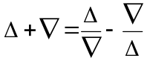, where and 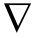 are forward and backward
difference operators respectively. [3M]

2. Find an approximate value of 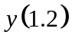 for the differential equation 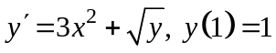
by Euler’s method. [3M]

3. Prove that 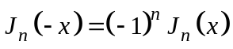, where is an integer. [3M]
4. Determine 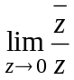, if it exists . [3M]
5. Perform first three approximations of bisection method to find a root of 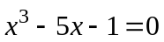. [3M]

6. Evaluate 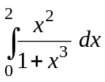 using Simpson’s rule with 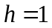. [2M]
7. Compute 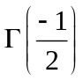. [2M]
8. State Cauchy-Riemann equations in polar form. [2M]

9. If 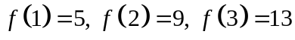 and 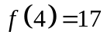, find 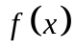. [2M]
10. Find the invariant points of the transformation 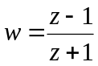. [2M]

Part – B
Max.Marks:50
ANSWER ANY FIVE QUESTIONS. EACH QUESTION CARRIES 10 MARKS.

1. a) Evaluate 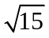 using the equation 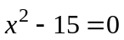 by the fixed point iteration method.
b) Solve the initial value problem 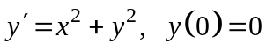 using Picard’s method of
successive approximation in 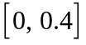 with 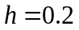.
2.a) Evaluate 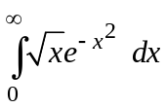 using Gamma function.
b) State Cauchy’s integral formula and hence evaluate 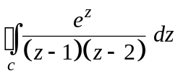, where is
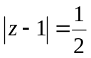.
3 a) Find the smallest positive root of the equation 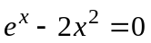 correct to three decimal
places by Newton-Raphson method.
b) Apply Trapezoidal rule to find an approximate value of 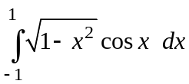 with 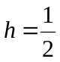.
4.a) Using Gauss forward interpolation formula to find 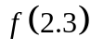 from the following data:
x: | 1 | 2 | 3 | 4 | 5
f(x): | 15.30 | 15.10 | 15.00 | 14.50 | 14.00

b) Find the Lagrange interpolating polynomial from the following data:

x: | -2 | 0 | 1 | 2
f(x): | 3 | 1 | -3 | -1
Hence find the approximate value of 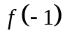.
5. a) Find the approximate value of 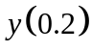 for 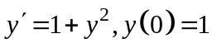 using Taylor series method.
b) Use Runge-Kutta method of order 4 to find for 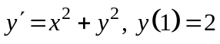.

6.a) Prove that 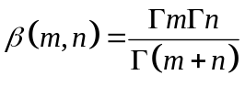.
b) Express 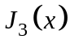 in terms of 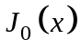 and 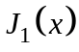.

7.a) Find the constants 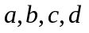such that the function 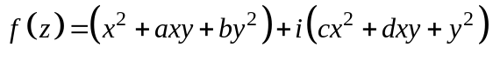
is analytic and express 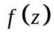in terms of .
b) State Cauchy’s residue theorem and hence evaluate 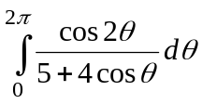.

8.a) Find the image of the closed disk 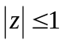 under the transformation 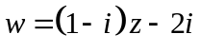 and
sketch the regions.
b) Obtain the bilinear transformation which maps the points 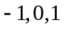 in the plane onto
the points 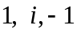 in -plane respectively.

-- 00 -- 00 --

